Patient Care Co-ordination Profile – States
Draft 1st Feb 2010
Author: Corrine Gower
Senior Advisor
Health System Interoperability and Standards
Information Strategy & Architecture
Information Directorate
National Health Board Business Unit
Ministry of Health, New Zealand

 | Is an/a | Plays Role Status of | Participates in acts of | Possible State
Person | Entity | Patient  Health Care Provider  System Administrator | Clinical Encounter  Non Clinical Encounter | Active (Alive)  Inactive (Deceased)  Nullified
Organisation | Entity | Service Provider  Location of care setting |  | Active  Inactive
Registry/Repository | Entity | Workflow management  Communication  Collaborative tool |  | Active  Inactive
Care Team | Entity |  |  | Active  Inactive
Non-organisation | Entity | Location of care setting | Clinical Encounter  Non Clinical Encounter | Active  Inactive
Co-ordination Plan | Entity |  |  | Active  Inactive
Goal | Entity |  |  | Active  Inactive
Task Report | Entity |  |  | Active  Inactive
Other document relating to clinical encounter event | Entity |  |  | Active  Inactive
Key Event Notification | Entity (not sure if an act or an entity, depends on profile user requirements) |  |  | Active  Inactive
Referral | Entity |  |  | Active  Inactive
Patient | Role |  | Clinical Encounter  Non Clinical Encounter | Role  Active  Cancelled  Nullified  Pending  Suspended  Terminated  Participation Status  Active  Cancelled  Completed  Nullified
Health Care Professional | Role | Care Manager  Case Manager  Case Team Member  Referral Dispatcher | Care Plan Co-ordination  Case Team Collaboration  Transfer of care  Referral transaction status  Recording Plan Task status  Clinical encounter documentation  Completing other documentation/administration  Key event notification | Role  Active  Cancelled  Nullified  Pending  Suspended  Terminated  Participation Status  Active  Cancelled  Completed  Nullified
Administrator | Role | Referral Dispatcher  System Administrator | Transfer of care  Referral transaction status  System Administration  Key event notification | Role  Active  Cancelled  Nullified  Pending  Suspended  Terminated  Participation Status  Active  Cancelled  Completed  Nullified
Care Plan Co-ordination  Case Team Collaboration  Transfer of care  Referral transaction status  Recording Plan Task status  Clinical encounter documentation  Completing other documentation/administration  Transfer of care  Referral transaction status  System Administration  Key Event Notification | Act |  |  | Aborted  Active  Cancelled  Completed  Held  New  Nullified  Obsolete  Suspended

Figure 1 Entity Status
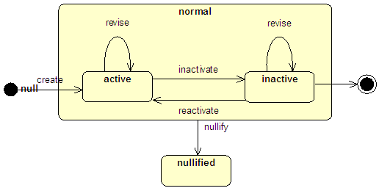

Figure 2 Role Status

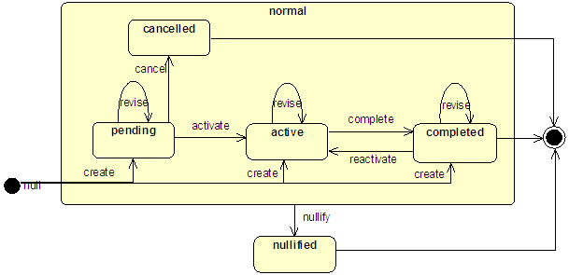

Figure 3 Managed Participation Status
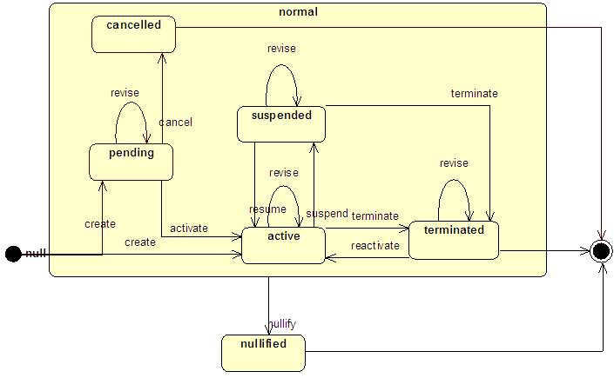

Figure 4 Act Status
